Accessible Syllabus Checklist

1. Include these course basics:
- Course title and number of credits
- Course designator and number
- Instructor's name
- Office location and contact information
- Course prerequisites (if any)
- Course description
- Student learning aims/outcomes
- Delivery Method: Day(s), time(s), and location(s) of face-to-face class meetings OR weekly cadence for online/hybrd classes
- Description of assignments, papers, projects, final exam (with due dates)
- Recommended readings and other materials (and where to locate them)
- Link to the Canvas course website
- Technology tools you plan on using throughout the course (exam proctoring, Flip, textbook accounts, etc...) so students can test or research each tool.
- Grading – e.g., course-specific grade definitions and criteria, weighting; comes near end of document.
- Student role/expectations (what learners need to do to meet course aims)
- Instructor role/expectations (what they can expect from you)
- Communication expectations (preferred communication method, where to ask questions in Canvas, feedback on assignment expectations, etc..)
- Course processes
  - Student Senate academic workload policy
  - Attendance policy
  - Policy for late work, exam make-up (written in light of newer campus policy for “legitimate absences,” which now includes parenting situations as excused
  - Statement on teamwork assessment, extra credit, service learning, revision
  - Your policy on incompletes
- U of M policies
- Course schedule

2. Format for digital accessibility
For guidance on building your accessibility skills check out the Digital Accessibility: Foundations in Training Hub and the AccessibleU website.
- Separate document sections using headings (using paragraph styles, rather than manual formatting) for screen readers and for ease of Table of Contents and/or Outline creation
- Create a table of contents (easy if your document uses paragraph styles)
- Embed hyperlinks in text (rather than copying the full text of the URL into the document)
- Create bulleted and numbered lists where appropriate (aids scannability)
- Ensure strong contrast between text and background colors (very dark against very light is a good rule)
- Add alternative text to all graphics or text boxes
- Format tables with a simple header row and include a description of the information contained in the table, i.e., a table summary

3. Set the tone with your course description and student aims/outcomes
Write course description and aims with students as your primary audience, e.g., address them as “you” rather than “the student will…”. Provide enough detail enough for students who may need to transfer credit. Provide an overview of activities and assessment; and be sure to use precise verbs in wording course aims/outcomes.

4. Weekly cadence
In an online course, a weekly cadence helps students plan how they will interact with the course each week. You can present this information to students as simple text, for example:

- Weekend: Complete recommended readings
- Monday: First response to class discussion due by 11:59pm
- Tuesday: Active learning activity due by 12 noon
- Wednesday: Second response to class discussion due by 11:59pm
- Thursday: Synchronous class meeting at 7:00pm
- Friday: Major assignments due by 11:59pm

You can also provide this information as a graphic, as in this example:

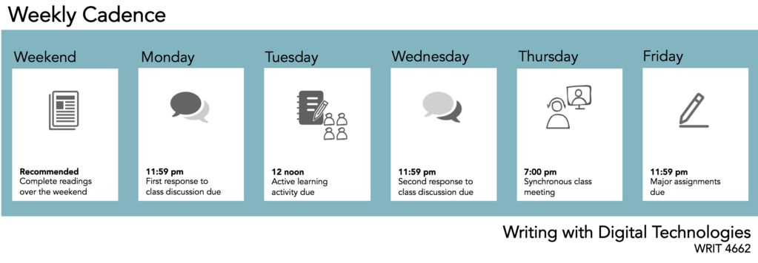
Make sure to add alternative text if you use a graphic (right-click to access alt-text).

4. U of M policies
A syllabus shared with University of Minnesota students must include, according to faculty senate endorsed policies, “copies of, references to, or statements on the following, and are encouraged to discuss elements of the policies particularly applicable to their course.”
This statement underscores the reality that instructors have options about how to shape policy segments of a course syllabus.
Instructors are required to address these nine areas:
- Grade definitions
- Scholastic dishonesty
- Makeup work for legitimate absences
- Student conduct code
- Sexual harassment
- Equity, diversity, equal employment opportunity, and affirmative action
- Disability Services
- Availability of mental health and stress management services
- Academic freedom and responsibility
However, instructors are not required to or limited to directly quote them. Instead, you should feel free to “own” these, and any others you include in your syllabus, by personalizing them to the context of your course.
Consider including statements on: special procedures or rules (e.g., accessing technology, field trips, etc.), course learning practices (e.g., activities, collaboration, device use in class), classroom climate (conduct, civility), academic integrity/misconduct, respect/harassment, accommodations for students with disabilities, and accommodation of religious observances.

5. Course schedule
The course schedule is a list of dates and topics that show the cadence of the course across the span of the semester. If you’re using a Canvas course website, most of this information can be located there. However, it is a courtesy to students to provide at least a high-level overview of the course, which includes:
- due dates for major assignments and exams
- due dates for assigned readings, homework, and other class preparations
- holidays and other times class does NOT meet
- final exam date, location and time (if applicable)

6. Resources to consult along the way
- UMN (Twin Cities policy information) ATSS accessible syllabus template; Duluth is currently (2022) launching Simple Syllabus
- University of Minnesota Policy Library, Syllabus Requirements (for Twin Cities, Rochester, Crookston, Morris); Duluth Syllabus Requirements.
- The full Syllabus Tutorial from the Center for Teaching and Learning, via the Way Back Machine.
- For reminders about selecting verbs in writing learning aims/outcomes, these two resources incorporate Bloom’s Taxonomy, one as a Task Wheel that links each level of learning to verbs and activities, and one that sets out Educational Origami's Digital Taxonomy with verb and activity suggestions that takes students into virtual realms in completing technology-enriched assignments.

