Plot Description—UPDATED 6-9-12
1. Using GPS navigate to plot center. Place center stake and lay out tapes to 12.5m in the 4 cardinal directions. Take Photos from the 4 cardinal directions looking inward, place an index card in the bottom right corner of each picture with the plot ID.
2. Record plot number, date, whether the exact plot center was found, Photo Numbers, aspect, slope, and slope position (see appendix) and anything else of note.
3. Record whether the plot was burned (Y/N/P ([P=partial]). If burned record fire (Ham< Cavity, Prescribed, or Multiple)
4. Record Char height (if applicable), Scorch height (if applicable) and Roy’s Tree Severity and Ground Severity Classes and Blowdown Severity

Tree Severity Index (< 8 m trees only)
0 = no damage
1 = needles scorched (most)
2 = most fine branches (< 1 cm)
3 = only nubs remain
4 = main stems or stubs remain

Ground Severity Index
0= unburned
1= light scorch
2= 1--50% surface litter
3= 50--99% surface litter
4= 100% surface, some duff
5= only mineral soil remaining

Blowdown Severity Index
0= No evidence of major wind damage, all trees are still standing, or if fallen have intact boles, Branches may be broken
1= Minor evidence of blowdown, most trees standing, but larger individuals and more wind susceptible species may have fallen or suffered bole breakage (<10% of canopy)
2= <50% of canopy trees have broken boles or have fallen and most wind firm species are undamaged
3= >50% of canopy trees have broken boles or have fallen, only wind tolerant species remain in canopy (although some may suffer damage or have fallen)
4= Wind Damage extensive. All canopy trees have broken boles or have fallen, sub-canopy of wind firm species may remain intact
5= All canopy trees and most sub-canopy trees are broken or have fallen, only standing stumps and immature trees (less than 5m in height) remain.

4. Record total vegetation cover, and then record tree, shrub, forb and gramminoid cover percents. Ocularly estimate percent cover for the entire plot; a 2mx2m square is approximately 1% of the coarse scale plot. Each cover layer shouldn’t exceed 100% but cover layers can add to more than 100%. Seedlings and saplings are included within the tree cover layer.
5. Enter all data in the PLOT_INFO data table.

Coarse Scale Trees
1. Record all trees over 5cm in DBH that fall within 5m and 12.5m of plot center. Ocularly estimate the size class (5-15cm, 15-25, >25) and record species, number of stems, live/dead and quadrat (A is toward Lake, B is Away).
For Live/Dead, categorize trees that are Live, Dead, and Down+Dead (trees that were blown down and have a continuous stem from root crown, or trees that have fallen because of consumption of soil organic layer).
2. Enter data into COARSE_TREES data table.

Fine Scale Trees
1. Measure and record all trees greater than 2.5 cm in DBH within 5m radius of plot center. (Measure DBH using a Diameter tape)
2. For LIVE/DEAD record either Live, Dead, Down+Dead.
a. For live canopy trees record canopy class (see Appendix) estimated height (to the nearest m), height to live crown and crown width (to the nearest .5m).
b. For all dead trees record decay class (see Appendix) as well as probable cause of mortality (either WIND, FIRE, OTHER, or UNKNOWN).

3. If either live or dead trees that are snapped or broken off, record height of break in meters and height to crown

4. Enter data into FINE_TREES data table.

Sapling and Seedling Plot
1. Measure all living trees and arborescent shrubs within a 3m of plot center. Record species, number, and size class (<10cm,10-50cm, 50-137cm, >137cm). For extremely numerous species (>30 stems) estimate number to the nearest five (ex. 35, 40, etc.).
3. Enter data into SAPLINGS_and_SEEDLINGS data table.

Cover Plot
1. Record the canopy cover % for each tree species over 2m tall.
2. Record the canopy cover % for each tree species less than 2m tall.
3. Record the canopy cover % for each shrub species over DBH.
4. Record the canopy cover % for each shrub species between 50cm and DBH.
5. Record the canopy cover % for each shrub species less than 50cm tall.
6. Enter data into COVER_PLOT data table

Appendix A from CSE Region 5

Aspect
Record the predominant setting aspect in degrees, 0° to 360°. Record in true north (i.e. always set the declination on your compass). Aspect may be determined from contour maps. Aspect is determined along the direction of slope for land surfaces with at least 5 percent slope in a generally uniform direction. Aspect is measured with a hand compass along the same direction used to determine slope.

- If aspect changes gradually across the setting, record an average aspect.
- If aspect changes across the setting but is predominately of one direction, code predominate direction, rather than the average.
- If the setting falls on or straddles a canyon bottom or narrow ridge top, code the aspect of the ridgeline or canyon bottom.
- If the setting falls on a canyon bottom or on a narrow ridge top, but most of the area lies on one side hill, code the aspect of the side hill.

Examples are:

Code | Description
0 | Flat
360 | 360°
72 | 72°
90 | 90°
999 | Indeterminate/No predominant aspect/Undulating

Slope
Record the angle of slope across the setting. Slope is determined by sighting the clinometer along a line parallel to the average incline (or decline). This angle is measured along the shortest pathway down slope before the drainage direction changes. To measure Slope, Observer 1 should stand at the uphill edge and sight Observer 2, who stands at the downhill edge. Sight Observer 2 at the same height as the eye-level of Observer 1. Read the slope directly from the percent scale of the clinometer.

- If slope changes gradually across the setting, record an average slope.
- If slope changes across the setting but the slope is predominately of one direction, code predominate slope percentage rather than the average.
- If the setting falls directly between two side hills, code the average slope of the side hill(s).
- If the setting falls on a canyon bottom or on a narrow ridge top, but most of the area lies on one side hill, code the slope of the side hill.

Slope Position (exactly 2 characters)
Record the position of the setting on the landscape. The definitions are from: Soil survey Staff. 1993. National Soil Survey Handbook (Title 430-VI) USDA Soil Conservation Service.

Code | Description
SU | Summit/Ridgetop/Plateau. The topographically highest hillslope position of a hillslope profile and exhibiting a nearly level surface.
SH | Shoulder. The hillslope position that forms the uppermost inclined surface near the top of a hillslope. It comprises the transition zone from backslope to summit.
BS | Backslope. The hillslope position that forms the steepest inclined surface and principle element of many hillslopes. In profile, backslopes are commonly steep, linear, and bounded by a convex shoulder above and descending to concave footslope. They may or may not include cliff segments. Backslopes are commonly erosional forms produced by mass movement and running water.
FS | Footslope. The hillslope position that forms the inner, gently inclined surface at the base of a hillslope. In profile, footslopes are commonly concave. It is a transition zone between upslope sites of erosion and transport.
TS | Toeslope. The hillslope position that forms the gently inclined surface at the base of a hillslope. Toeslopes in profile are commonly gentle and linear, and are constructional surfaces forming the lower part of a hillslope continuum that grades to a valley bottom.
VB | Valley Bottom. Wide valley bottom beyond influence of toeslope.

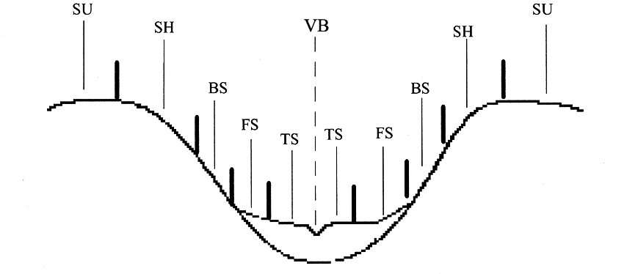
Slope Position

DBH
DBH is outside bark diameter at 4.5 feet above the forest floor on the uphill side of the tree. To determine breast height, the forest floor includes the duff layer that may be present, but does not include unincorporated woody debris that may rise above the ground line. If a dead tree (snag) is missing bark, measure the DBH without the bark and record that measurement.

Forked tree: In order to qualify as a fork, the stem in question must be at least 1/3 the diameter of the main stem and must branch out from the main stem at an angle of 45 degrees or less. Forks originate at the point on the bole where the piths intersect. Forked trees are handled differently depending on whether the fork originates above or below 4.5 feet.

Trees forked below 4.5 feet are treated as distinctly separate trees. DBH is measured for each stem at 4.5 ft above the ground.

Trees forked at or above 4.5 feet count as one tree. If a fork occurs at or immediately above 4.5 ft, measure diameter below the fork just beneath any swelling that would inflate DBH.

Stump sprouts originate between ground level and 4.5 ft on the boles of trees that have died or been cut. Stump sprouts are handled the same as forked trees, with the exception that stump sprouts are not required to be 1/3 the diameter of the dead bole. Stump sprouts originating below 1.0 ft are measured at 4.5 ft from ground line. For multi-stemmed woodland species, treat all new sprouts as part of the same new tree.

Tree with irregularities at DBH: On trees with swellings, bumps, depressions, and branches at DBH, diameter will be measured immediately above the irregularity at the place it ceases to affect normal stem form. If this is not possible, because of the vertical extent of the irregularity, then adjust the DBH measurement to better reflect the diameter of a regular bole.

Tree on slope: Measure diameter at 4.5 ft from the ground along the bole on the uphill side of the tree.

Leaning tree: Measure diameter at 4.5 ft from the ground along the bole.

Independent trees that grow together: If two or more independent stems have grown together at or above the point of DBH, continue to treat them as separate trees.

Missing wood or bark: If 50% or more of the circumference of the bole is intact, reconstruct the diameter at DBH.

Diameter on stump: Use a logger's tape, cloth tape, or ruler to measure the longest and shortest axis across the top of the stump. Record the diameter as the average of the two measurements.

Proper Use of a Diameter Tape
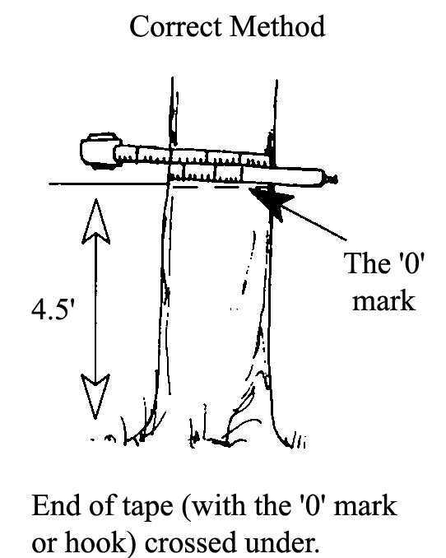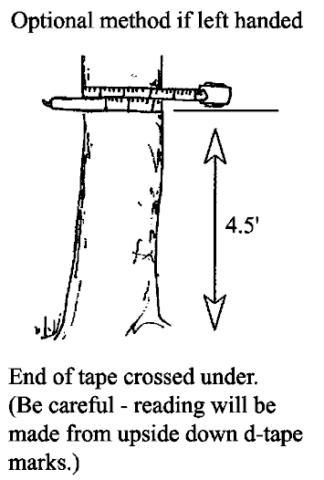

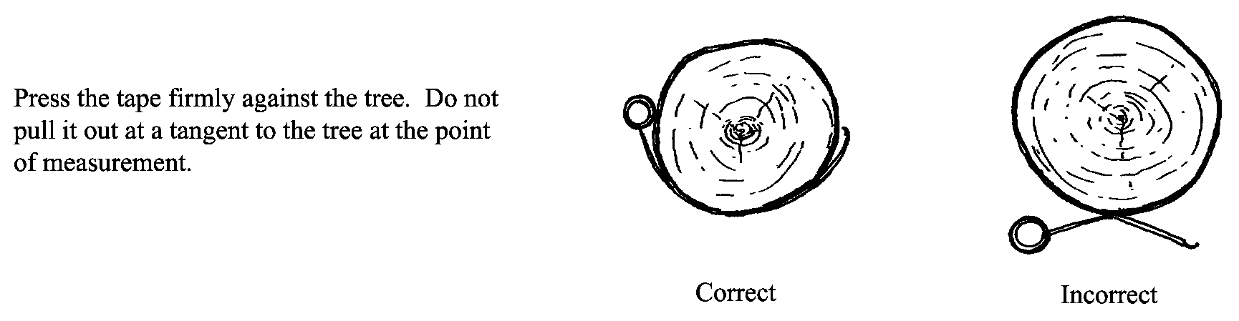

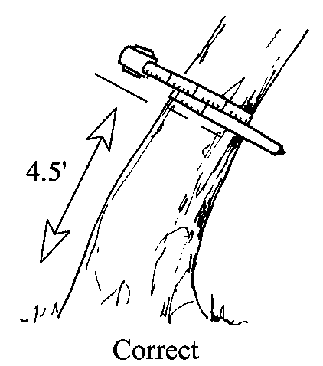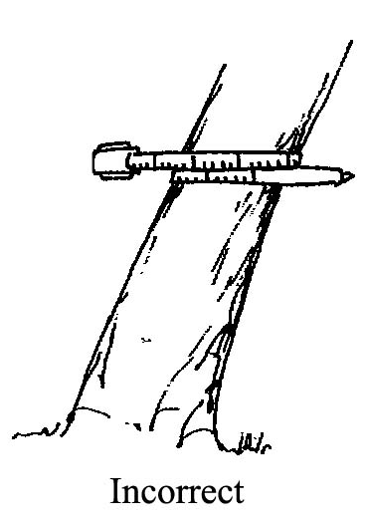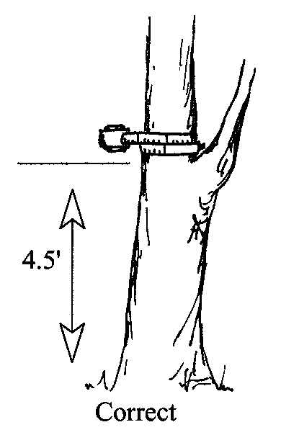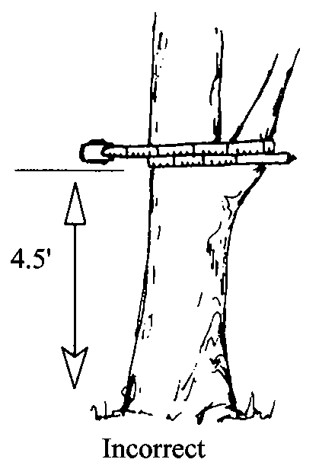
Tape must be at right angles to lean of tree. Do not place tape at abnormal location on bole of tree.

Crown Width (maximum of 3 numbers)
Record the average crown width, in feet.

Crown width is the average of two measurements: 1) widest distance anywhere in the crown between the outer ends of two live branches (the drip line); and 2) the distance perpendicular to the widest measurement. Abnormally long branches sticking out beyond the edge of the crown are not used in establishing the extent of a crown.

A tree’s widest crown measurement, if viewed from the air, is the diameter of a circle including all foliage. Measure it at the crown’s widest point with a tape held by two crew people standing under opposite drip lines at the crown’s edges. Make the second measurement at 90 degrees to the crown diameter at the widest point using the same procedures.

With shoulders parallel to the tape, determine drip line end points by looking up perpendicular to the tape and projecting where crown edge branch tips would hit the ground if they fell. Occasionally, a branch may protrude abnormally, but the lateral crown line is drawn across the portion of the branch, which includes the “normal outline” of the tree. It is helpful to use a device, such as a clinometer, that allows the observer to measure a line perpendicular to the ground. The clinometer should be used for training and to check estimates made during the operational field season. If you cannot see the crown edge from directly beneath the drip line, both observers should move an equal distance away from the tree and make your estimate. All measurements are rounded to the nearest foot. Crown width measurements or estimates can be used to compute crown volume and surface area.
Accuracy Standard: ± 10 % for intensive exams
± 20 % for extensive and quick plot exams

Point of Measurement for DBH

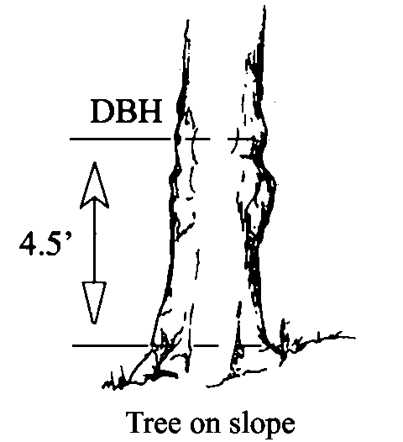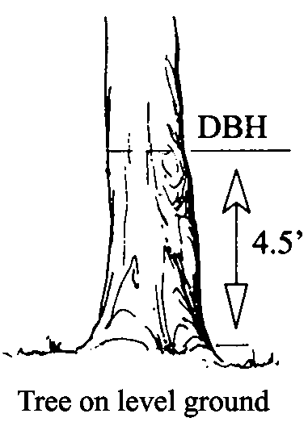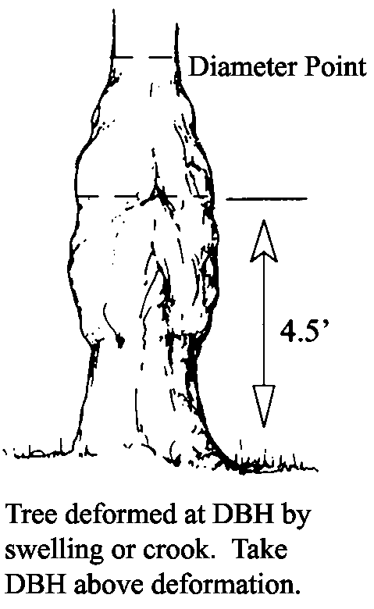

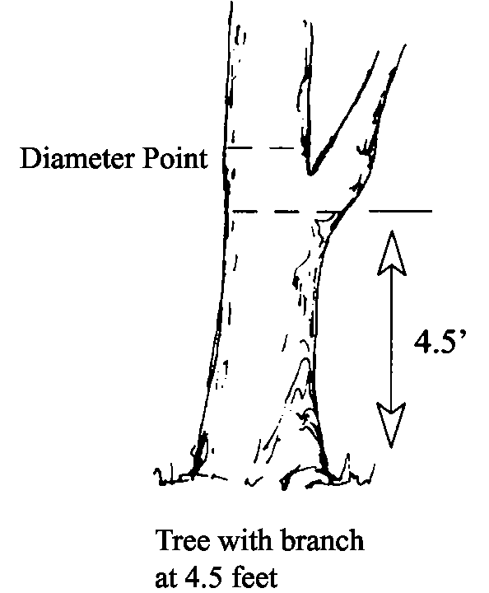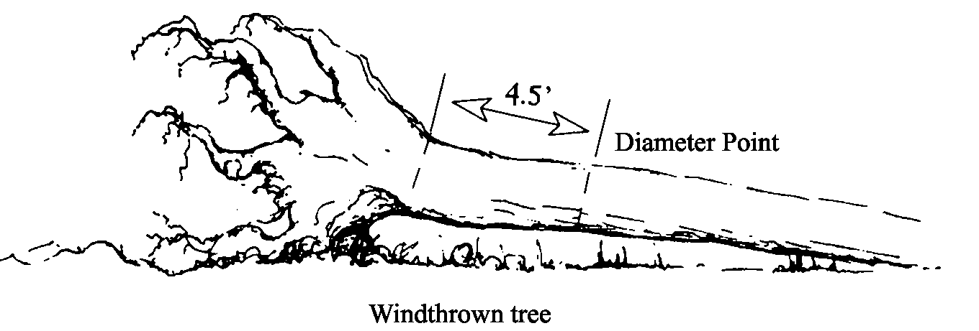

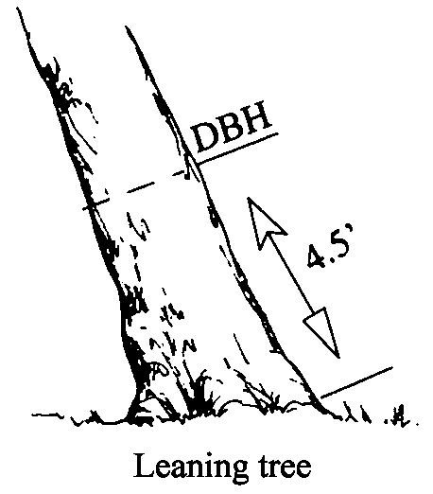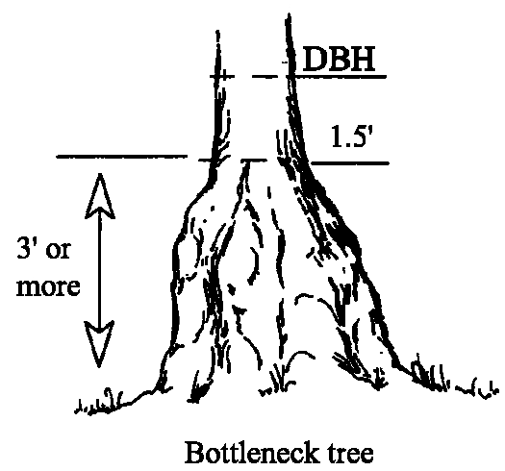

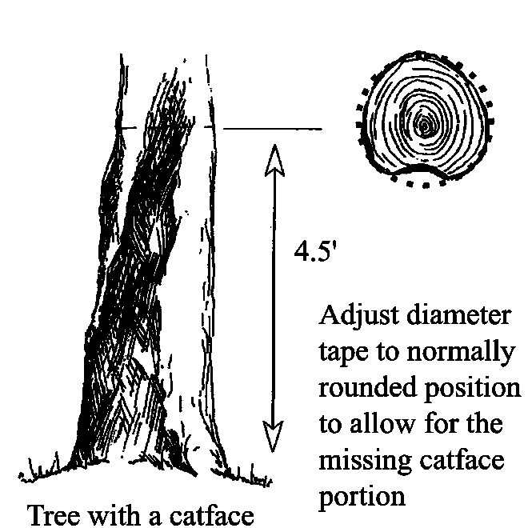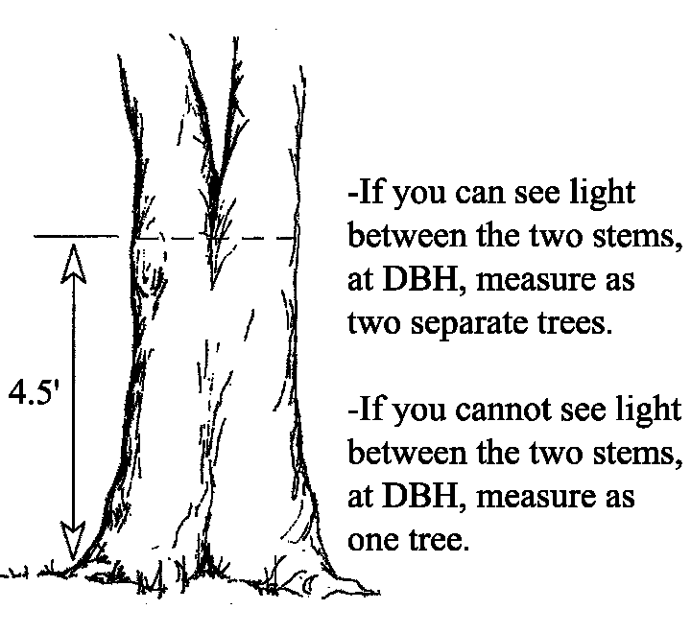

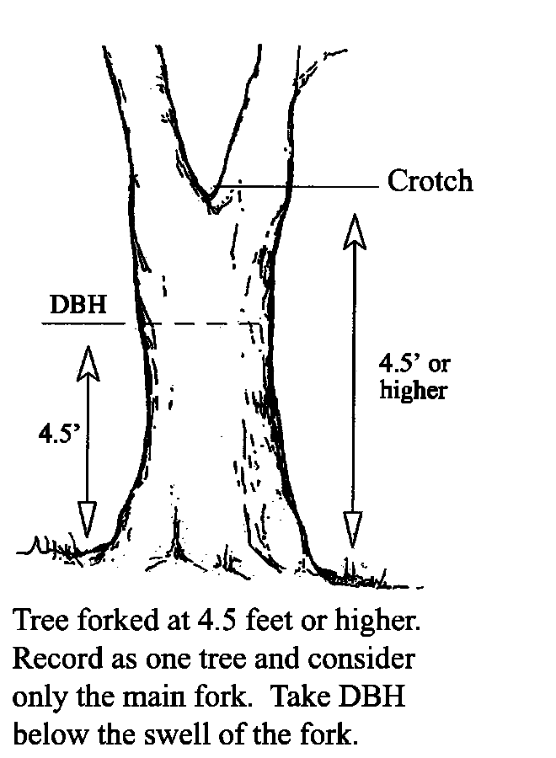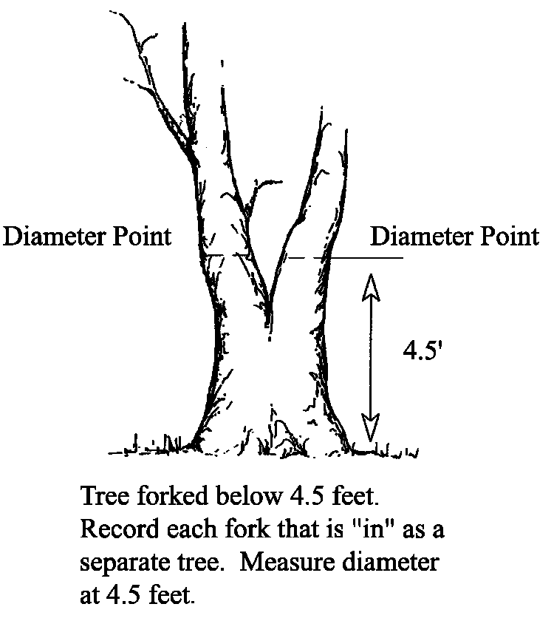

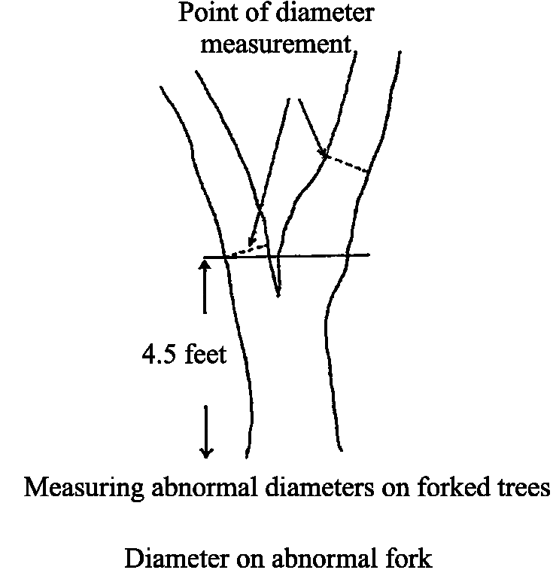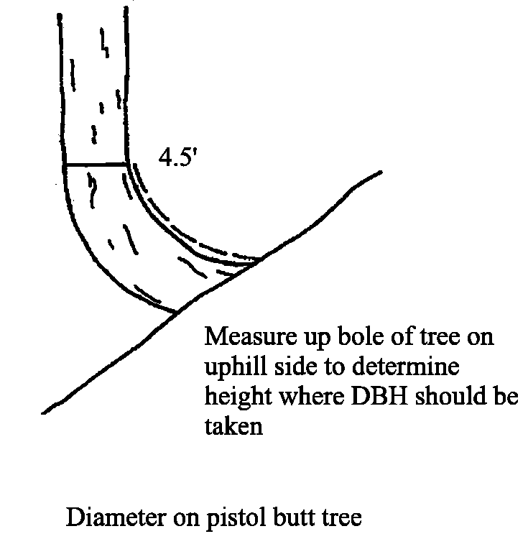

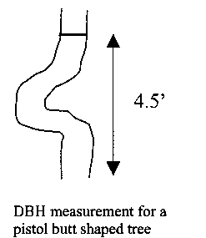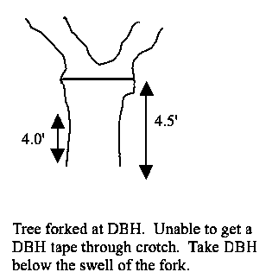

Crown Class (exactly 2 characters)
Record the crown class for all live trees. Crown class is the description of the relative position of the tree crown with respect to competing vegetation surrounding the tree. Crown classes are a useful descriptor of competitive status of trees in all structural types of stands. The Crown Class for each tree is determined in the context of competition for sunlight or moisture between the subject tree and its immediate environment, trees, or shrubs.

Classifications are more difficult to assign in uneven-aged stands or in plots where more than one stand is present. In these situations, classify the tree based on its immediate environment. Base your classification on how much light the tree’s crown is receiving, not its position in the canopy. The intermediate and overtopped crown classes are meant to include trees seriously affected by direct competition with adjacent trees. For example, a young, vigorous tree that is considerably shorter than other trees in the stand but not overtopped by other trees, and receives full light from above and partly from the side, is classified as dominant. The same principle applies to two-storied stands: understory trees should only be assigned subordinate crown classes if they are adjacent to overtopping trees. In plots with scattered residual overstory trees over younger trees, a considerable portion of the understory trees will be classified as dominant or codominant.

Code | Name | Description
OP | Open-grown or Isolated | Tree crowns receive full light from above and from all sides. In even-aged stands, these trees have their crowns well above the general canopy.
DO | Dominant | Tree crowns receive full light from above and partly from the sides. Crowns extend above the general level of the crown cover of others of the same stratum and are not physically restricted from above, although possibly somewhat crowded by other trees on the sides.
CO | Codominant | Tree crowns receive full light from above, but comparatively little from the sides. Crowns form a general level of crown stratum, are not physically restricted from above and are crowded by other trees from the sides.
IN | Intermediate | Tree crowns occupy a definitely subordinate position and are subject to strong lateral competition from crowns of dominants and codominants. They receive little direct light from above through small holes in the canopy, but no light from the sides.
OV | Overtopped | Tree crowns receive no direct light from above or from the sides and are entirely below the general level of dominant and codominant trees.
RE | Remnant | Trees that remain from a previous management activity or catastrophic event. The tree is significantly older than the surrounding vegetation. Remnant trees do not form a canopy layer and are usually isolated individuals or small clumps. This definition is from the Region 6 Inventory and Monitoring System field procedures for the Current Vegetation Survey.
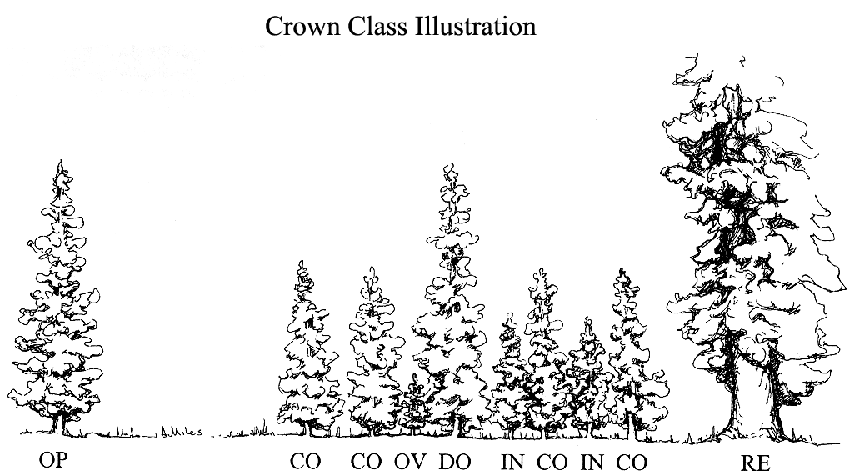

Snag Decay

Code | Bark | Heartwood Decay | Sapwood Decay | Limbs | Top Breakage | Bole Form | Time Since  Death
1* | Tight, intact | Minor | None to incipient | Mostly Present | May be present | Intact | ≤5 years
2 | 50% loose or missing | None to advanced | None to incipient | Small limbs missing | May be present | Intact | >5 years
3 | 75% missing | Incipient to advanced | None to 25% | Few remain | Approx. 1/3 | Mostly intact | >5 years
4 | 75% missing | Incipient to advanced | 25%+ | Few remain | Approx. 1/3 to ½ | Losing form, soft | >5 years
5 | 75%+ missing | Advanced to crumbly | 50%+ advanced | Absent | Approx. ½+ | Form mostly lost | >5 years
*Implies recent mortality, within the last 5 years.

Snag Decay Classes
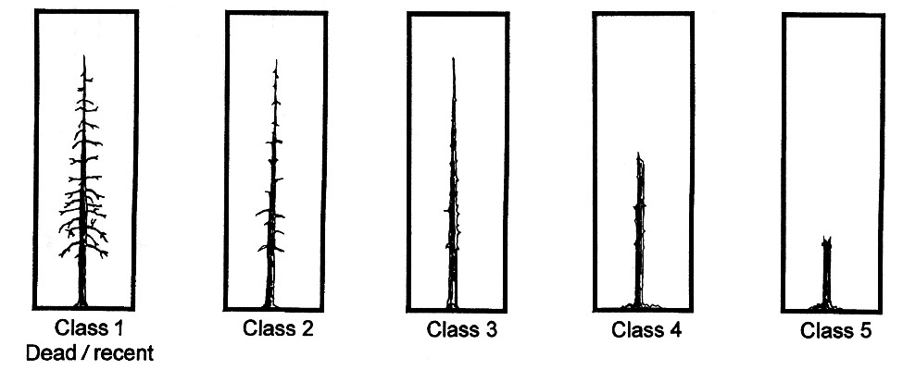

Definitions for disturbance classes

Undisturbed: Burn= N and wind severity<=.25

High Severity Blowdown: Burn=N and wind severity >=.75 or >=3

Mod Blowdown: Burn=N and wind severity <.75 or <3

Fire alone No wind: Burn= Y or P and wind severity<=.25

Sev Blowdown and Fire: Burn=Y and wind severity >=.75 or >=3

Blowdown+Rx+Ham
Multiple

Severity for single disturbances
Vlow =10% BA killed
Low = 10-40%
40-70% Moderate
70-100%High

